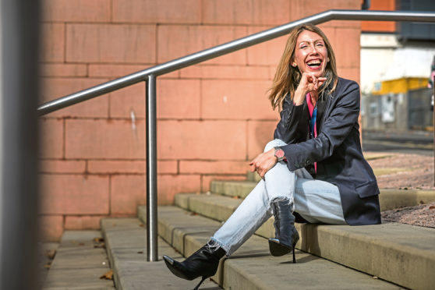

BSc PsyDip MSc PhD PGDip Counselling CPsychol (Health) FHEA AFBPsS

Dr Zoë Chouliara, Formerly Professor in Mental Health, Consultant Counselling & Health Psychologist, Senior Consulting Psychologist, Practitioner Counselling & Health Psychologist, Psychotherapist/Counsellor & Supervisor/Trainer: Zoë is an award winning clinical academic. She has 14 years of clinical experience and 10 years of clinical supervisory experience in working with severe and/or complex presentations across sectors, including the NHS, voluntary and independent sector. She has delivered talks and clinical workshops nationally and internationally. Her clinical expertise is on the following areas: Recovering from Severe Adversity/Childhood Abuse; 2. Severe and/or Complex Appearance Distress/ Plastic Surgery & Dermatology; 3. Sense of Self & Identity/ Gender incongruence 4. Recovering from Post COVID Syndrome/Post-viral syndromes. She is highly experienced and skills in psychological assessment in general adult mental health but most importantly in assessments for plastic surgery as well as gender incongruence. Zoë is a research leader with a portfolio of publications and impactful funded research in recovering from childhood abuse/complex trauma and dermatological conditions/appearance distress. She is the lead author of the Acts of Recovery, the first research-based, survivor-centred self-help resource for survivors of childhood abuse (Named in the Top 100 Nation’s Lifesavers List, May 2019). She has been awarded the BJN Dermatology Award 2016, as part of the team of expert trainers delivering the first ever Dermatology Masterclass nationally and internationally. She is currently based as locum Consultant in the SE Trust Belfast, Post COVID Psychology Service. She has successfully led a specialist psychology in plastics service in NHS Tayside for three years, one out of only four similar services in the country. She has also been an honorary practitioner counselling psychologist 8a within Dermatology NHS Tayside for 3 years. She was a volunteer clinician with the Medical Foundation (now Freedom from Torture), where she practised clinically with survivors of torture/organised violence. She is one out of a few practitioner psychologists in the UK and internationally with clinical experience in the field of human rights and organised violence. She is Past Chair of the British Psychological Society (BPS), ex Assistant Chief Supervisor for Health Psychology, Associate Fellow of the BPS and Fellow of the Higher Education Academy. She is the first practitioner psychologist to sit in the Cross- Party Group on Skin & Associated Rheumatic Conditions. She is currently in independent practice and in addition to her own practice, she offers clinical services as a Senior Consulting Psychologist at YourGP Edinburgh and in the Purple House Clinic Glasgow. She is also currently based on the NHS as a Consultant Psychologist locum within Clinical Health. Zoë has been a leader in her field and as a Professor has led various groups to success in academia and in professional training counselling courses, as a strategic leader. She has delivered training and clinical workshops nationally and internationally in conferences and in prestigious HEIs. She is well published, loved by the public who have attended her professorial lecture and symposia by hundreds, and also loved by the media with many interviews and pieces on key topics. Her videos are available to watch on YouTube and Vimeo.
Email: zoe.choulara@outlook.com  Tel. 07742728169 | 